HUMAN NATURE
Thales- water
Anaximenes- air
Anaximander- immaterial, boundless, animal
Heraclitus-constant change
Pythagoras- purification of soul, reincarnation
Protagoras-man measure of all things, criterion of truth
Socrates- human thinks and wills, attitudinal level
Plato- dualism,body &sou, body immaterial, soul-immaterial
Aristotle- state of unity, inseparable
Stoics-part of determined universe, soul is matter w/ 7 parts, conform with God & nature

GREEK PHILOSOPHERS

St. Augustine- free will makes imperfect but capable of perfection when do good
St. Thomas Aquinas- intellect and will
MODERN PHILOSOPHERS PPPHIPHILOLOSOPHYLOPHILOSOPHERS LOSOPHERS
Rene Descartes- man is machine & thinking being, man is substance
Karl Marx- man is labor
Thomas Hobbes- physical objects, sophisticated machines, anti-social, egoistic
Martin Buber- individual & social being
Jean Jacques Rousseau- essentially good, social contract

MEDIEVAL PHILOSOPHERS
Jean-Paul Sartre- no human nature, he conceives himself
Martin Heidegger-not dipartite body & soul but process of existence
Soren Kierkegaard- collective idea, crowd existence
Karl Jasper- existent-being, other-related, Encompasssing
Viktor Frankl-will for existence, logotheraphy
John Stuart Mill- utilitarianism, happiness
Jeremy Bentham- pain & pleasure

Buddhism- chain of life,baby to adult,
Taoism- Inner nature,n Tao is ONE THING connects w/ many things
Confucianism-social code of behavior, stresses importance of education for moral development for moral virtue, man concerned HUMAN DESTINY, self-transcendence

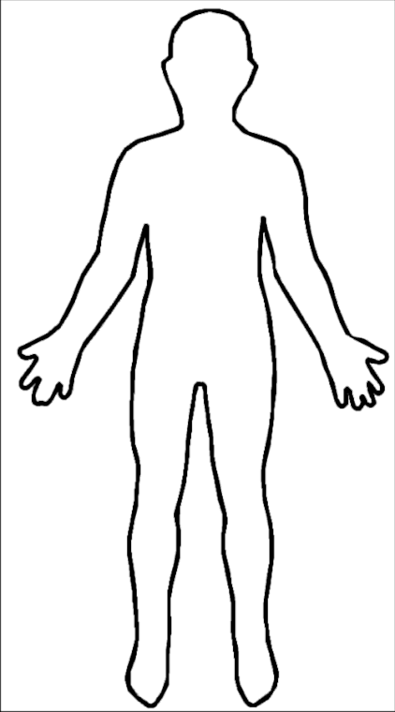
EASTERN PHILOSOPHERS
EXISTENTIAL PHILOSOPHERS

